**Choco**

**Extro Tall Boy Basin Mixer** - Product Description:

Extro Tall Boy Basin Mixer is a perfect blend of style and functionality, designed for modern countertop and vessel basins. Its tall, elegant structure combined with single-lever ease offers a smooth user experience and enhances the aesthetics of any premium bathroom space.

**Key Features**:

✅ Tall Body design perfect for vessel basins

✅ Single-lever temperature & flow control

✅ Durable chrome Finish brass with corrosion-resistant, long-lasting shine

✅ Premium Ceramic Cartridge – Leak-proof and long operational life

✅ Hot & Cold Mixer – Designed for dual water supply

**Product Specifications**

**Brand:** Extro

**Model:** Tall Boy Basin Mixer

**Material:** High-Quality Brass

**Finish:** Chrome Plated

**Mount Type:** Deck Mounted

**Operation:** Single Lever

**Water Connection:** Hot & Cold

**Application:** Table Top / Vessel Basin

**Cartridge Type:** 35mm Ceramic Disc Cartridge

**Connection Size:** ½ inch BSP

**Warranty:** Typically 5 Years

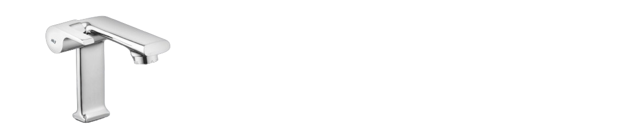

**Extro Wall Mixer -** Product Description

The **Extro Wall Mixer** is an elegant wall-mounted faucet designed to combine hot and cold water effortlessly for your wash basin or bath area. With its sleek, compact body and ergonomic single-lever handle, it delivers not only functional convenience but also a modern aesthetic. Ideal for stylish bathrooms, this mixer ensures smooth water flow and long-lasting performance.

**Key Features**

* ✅ Sleek and compact wall-mounted design
* ✅ Single lever control for hot and cold water mixing
* ✅ Premium chrome finish – Rust and corrosion resistant
* ✅ Smooth ceramic disc operation for leak-proof performance
* ✅ Ergonomically designed handle for easy operation
* ✅ Suitable for wash basins, bath spouts, and overhead showers

**Product Specifications**

* **Brand:** Extro
* **Model:** Wall Mixer
* **Material:** Solid Brass
* **Finish:** Polished Chrome
* **Mount Type:** Wall Mounted
* **Operation Type:** Single Lever
* **Water Supply:** Hot & Cold
* **Valve Mechanism:** Ceramic Disc Cartridge
* **Application:** Basin, Bathtub, or Shower
* **Connection Size:** 15 mm (½ inch BSP)
* **Warranty:** Typically 5 Years (Confirm with dealer)

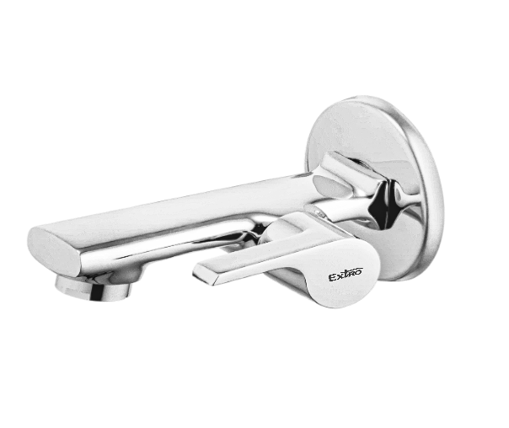

**Extro Wall Spout with Tip-Ton Knob**

**Product Description**

The **Extro Wall Spout with Tip-Ton Knob** is a sleek and compact water outlet ideal for use with bath tubs or wall-mounted systems. Designed with a built-in diverter tip-ton knob, it allows quick switching between spout flow and overhead shower. Its durable brass construction and polished chrome finish offer a modern look and long-lasting performance.

**Key Features**

* ✅ Sleek wall-mounted design for space-saving installation
* ✅ Built-in tip-ton knob for diverter functionality
* ✅ Smooth water flow for tub filling or bath applications
* ✅ High-grade chrome-plated finish – resistant to corrosion
* ✅ Durable brass body construction
* ✅ Compatible with overhead showers and diverter systems

**Product Specifications**

* **Brand:** Extro
* **Model:** Wall Spout with Tip-Ton Knob
* **Material:** Solid Brass
* **Finish:** Chrome Plated
* **Mount Type:** Wall Mounted
* **Functionality:** Spout with Tip-Ton Diverter
* **Connection Size:** 15 mm (½ inch BSP)
* **Application:** Suitable for bath spouts and shower systems
* **Warranty:** Typically 5 Years (Confirm with dealer)

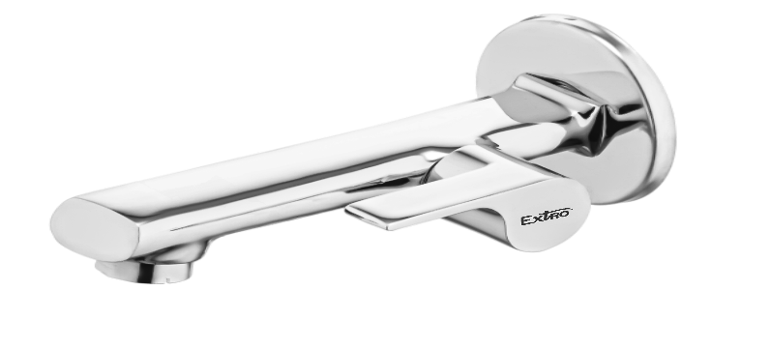

**Extro Nozzle Bib Cock with Wall Flange**

**Product Description**

The **Extro Nozzle Bib Cock** is a premium wall-mounted tap designed for effortless operation and durability. Equipped with a nozzle outlet, it's perfect for connecting garden hoses, washing machine pipes, or health faucets. Crafted from high-quality brass and finished in polished chrome, it adds functionality and elegance to any space—ideal for utility areas, bathrooms, and balconies.

**Key Features**

* ✅ Wall-mounted nozzle bib tap for multi-purpose use
* ✅ Chrome-plated brass body – durable and corrosion-resistant
* ✅ Single lever handle for smooth control
* ✅ Compatible with hoses, washing machine, or bidet spray
* ✅ Includes wall flange for a clean installation finish
* ✅ Easy to install and maintain

**Product Specifications**

* **Brand:** Extro
* **Model:** Nozzle Bib Cock
* **Material:** Solid Brass
* **Finish:** Chrome Plated
* **Mount Type:** Wall Mounted
* **Handle Type:** Single Lever
* **Outlet Type:** Nozzle with threading for pipe or hose
* **Connection Size:** 15 mm (½ inch BSP)
* **Application:** Health faucet, washing machine, garden hose
* **Wall Flange:** Included
* **Warranty:** Typically 5 Years (Confirm with dealer)

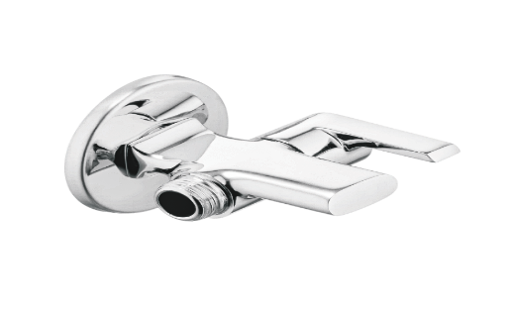

**Extro Concealed Stop Cock**

**Product Description**

The **Extro Concealed Stop Cock** is a sleek and robust valve designed to control water flow discreetly behind walls or tiles. Perfect for bathrooms and kitchens, this stop cock combines durable brass construction with a polished chrome handle for smooth operation and lasting performance. Ideal for isolating water supply to showers, geysers, or basin mixers.

**Key Features *(Single-line format)***

✅ Concealed design for a clean and modern appearance  
✅ Easy-flow quarter-turn operation for quick shut-off  
✅ Durable brass body for high pressure and long life  
✅ Corrosion-resistant chrome finish handle  
✅ Suitable for both hot and cold water lines

**Product Specifications**

* **Brand:** Extro
* **Model:** Concealed Stop Cock
* **Material:** Brass Body with Chrome-Plated Handle
* **Finish:** Brass Body (Natural) + Chrome Handle
* **Mount Type:** Concealed / Wall Fitted
* **Operation:** Quarter-turn mechanism
* **Handle Type:** Lever Handle
* **Connection Size:** 15 mm (½ inch BSP)
* **Application:** Shower, geyser, basin mixer inlet
* **Warranty:** Typically 5 Years (Confirm with dealer)

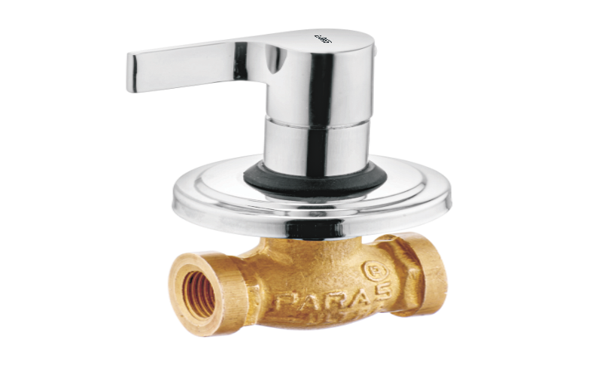

**Extro 2-in-1 Wall Mixer with Provision for Overhead Shower**

**Product Description**

The **Extro 2-in-1 Wall Mixer** offers combined functionality of a spout and an overhead shower connection in one sleek, compact unit. Designed for modern bathrooms, this mixer allows seamless switching between bath and shower use. Its ergonomic single-lever operation and durable chrome-plated finish make it a reliable and stylish addition to any bathing area.

**Key Features *(Single-line format)***

✅ Dual-function outlet for spout and overhead shower  
✅ Smooth single-lever operation for hot and cold water  
✅ Corrosion-resistant chrome finish for long-lasting shine  
✅ Sturdy brass construction for strength and durability  
✅ Ideal for modern bath spaces with limited fittings

**Product Specifications**

* **Brand:** Extro
* **Model:** 2-in-1 Wall Mixer
* **Material:** Solid Brass
* **Finish:** Chrome Plated
* **Mount Type:** Wall Mounted
* **Operation:** Single Lever with Shower Provision
* **Water Supply:** Hot & Cold
* **Application:** Bath and Overhead Shower Use
* **Connection Size:** 15 mm (½ inch BSP)
* **Warranty:** Typically 5 Years (Confirm with dealer)

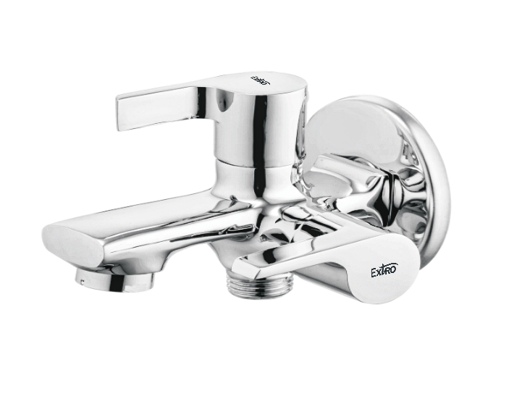

**Extro 2-Way Bib Cock with Dual Control**

**Product Description**

The **Extro 2-Way Bib Cock with Dual Control** is a versatile wall-mounted faucet designed to manage two water outlets from a single point. Its dual-handle system allows independent control of both outlets—ideal for use with health faucets, washing machines, or garden hoses. Engineered from solid brass and finished in chrome, it ensures durability and sleek style in utility or bathroom settings.

**Key Features *(Single-line format)***

✅ Dual outlet operation for health faucet, washing machine, or garden hose  
✅ Independent control levers for both outlets  
✅ Premium chrome finish for long-lasting shine and corrosion resistance  
✅ Strong brass body ensures durability under high pressure  
✅ Includes wall flange for a clean and secure installation

**Product Specifications**

* **Brand:** Extro
* **Model:** 2-Way Bib Cock with Dual Control
* **Material:** Solid Brass
* **Finish:** Chrome Plated
* **Mount Type:** Wall Mounted
* **Handle Type:** Dual Lever Control
* **Outlet Type:** Two outlets – nozzle and front spout
* **Connection Size:** 15 mm (½ inch BSP)
* **Application:** Washing machine, bidet spray, garden hose, utility tap
* **Warranty:** Typically 5 Years (Confirm with dealer)

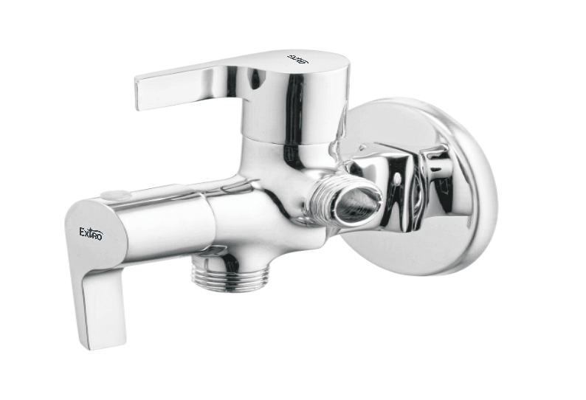

**Extro Swan Neck Bib Cock with Wall Flange**

**Product Description**

The **Extro Swan Neck Bib Cock** combines elegant design with practical functionality, making it ideal for wash basins or kitchen sinks. With a tall, swan-shaped spout and smooth quarter-turn operation, it provides ample space and ease of use. Made from solid brass with a chrome finish, it offers both style and durability for everyday utility.

**Key Features *(Single-line format)***

✅ Stylish swan neck design for extended reach and elegance  
✅ Tall spout provides better clearance for sink or basin use  
✅ Durable brass body with corrosion-resistant chrome finish  
✅ Smooth single lever for precise water flow control  
✅ Wall flange included for clean and secure installation

**Product Specifications**

* **Brand:** Extro
* **Model:** Swan Neck Bib Cock
* **Material:** Solid Brass
* **Finish:** Chrome Plated
* **Mount Type:** Wall Mounted
* **Spout Type:** Swan Neck (Tall Spout)
* **Handle Type:** Single Lever
* **Connection Size:** 15 mm (½ inch BSP)
* **Application:** Kitchen sink, wash basin, utility use
* **Warranty:** Typically 5 Years (Confirm with dealer)

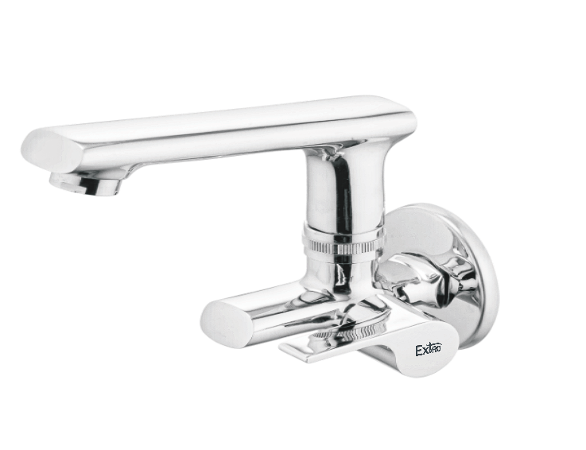

**Extro Tall Boy Basin Mixer**

**Product Description**

The **Extro Tall Boy Basin Mixer** is a premium single-lever mixer tap designed for countertop basins and vanities. With its tall body and sleek, contemporary design, it offers exceptional water flow control and visual appeal. Constructed from solid brass with a lustrous chrome finish, it provides long-lasting performance and adds modern sophistication to any bathroom décor.

**Key Features *(Single-line format)***

✅ Tall body ideal for countertop wash basins  
✅ Single lever for smooth hot and cold water mixing  
✅ Corrosion-resistant chrome finish for lasting shine  
✅ Brass construction ensures high durability and strength  
✅ Sleek modern design enhances bathroom aesthetics

**Product Specifications**

* **Brand:** Extro
* **Model:** Tall Boy Basin Mixer
* **Material:** Solid Brass
* **Finish:** Chrome Plated
* **Mount Type:** Deck Mounted
* **Handle Type:** Single Lever
* **Water Supply:** Hot and Cold
* **Cartridge Type:** Quarter-turn ceramic disc
* **Connection Size:** 15 mm (½ inch BSP)
* **Application:** Countertop basins in modern bathrooms
* **Warranty:** Typically 5 Years (Confirm with dealer)

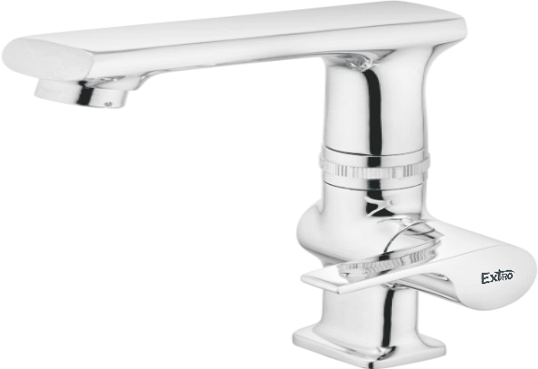

**Extro Wall Mixer Telephonic with L Bend**

**Product Description:**

The Extro Wall Mixer Telephonic with L Bend is a premium-quality bath fitting that combines convenience, modern aesthetics, and multipurpose utility. Designed for wall-mounted installation, it includes a telephonic shower connection and an L bend for overhead shower attachment, making it a complete solution for contemporary bath spaces. Its robust brass construction and gleaming chrome finish ensure durability and elegance.

**Key Features (Single-line format)**

✅ Telephonic outlet for hand shower compatibility  
✅ L bend included for overhead shower connection  
✅ Corrosion-resistant chrome finish with lasting shine  
✅ Single lever control for hot and cold water mixing  
✅ Sturdy brass construction for long-term reliability

**Product Specifications**

**Brand:** Extro  
**Model:** Wall Mixer Telephonic with L Bend  
**Material:** Solid Brass  
**Finish:** Chrome Plated  
**Mount Type:** Wall Mounted  
**Handle Type:** Single Lever  
**Water Supply:** Hot and Cold  
**Diverter:** Yes (for bath, telephonic shower & overhead use)  
**Connection Size:** 15 mm (½ inch BSP)  
**Application:** Bath and shower area in modern bathrooms  
**Warranty:** Typically 5 Years (Confirm with dealer)

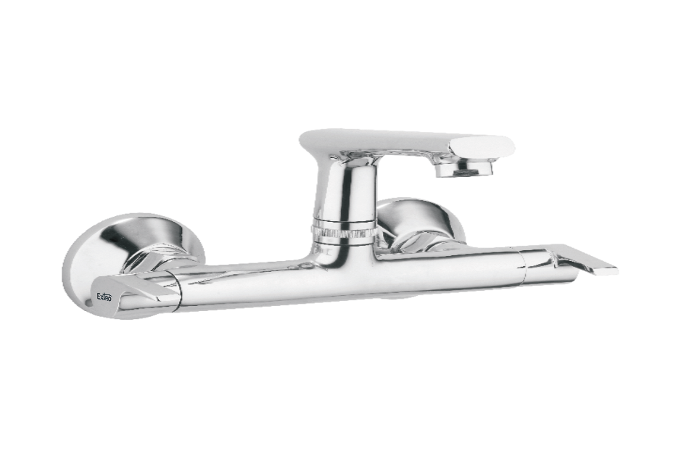

**Extro Wall Mixer with Overhead & Spout**

**Product Description:**

The Extro Wall Mixer with Overhead and Spout is a compact, elegant fixture designed for modern bathrooms, combining both overhead shower and spout functionality in a single, sleek unit.

**Key Features (Single-line format)**

✅ Dual functionality with spout and overhead shower outlet  
✅ Sleek chrome-plated finish for modern bathroom aesthetics  
✅ Single lever for effortless water flow and temperature control  
✅ Solid brass body for enhanced strength and durability  
✅ Wall-mounted design ensures space-saving installation

**Product Specifications**

**Brand:** Extro  
**Model:** Wall Mixer with Overhead & Spout  
**Material:** Solid Brass  
**Finish:** Chrome Plated  
**Mount Type:** Wall Mounted  
**Handle Type:** Single Lever  
**Water Supply:** Hot and Cold  
**Diverter:** Yes (spout and overhead shower)  
**Connection Size:** 15 mm (½ inch BSP)  
**Application:** Bath and overhead shower setups  
**Warranty:** Typically 5 Years (Confirm with dealer)

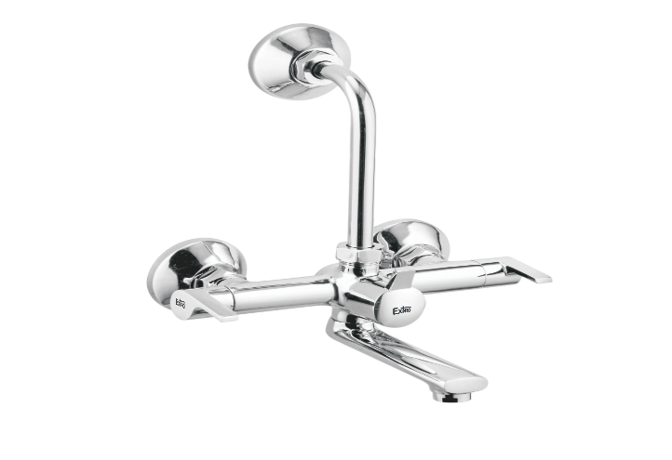

**Extro Wall Mixer Telephonic with Overhead Shower Arm**

**Product Description:**

The Extro Wall Mixer Telephonic with Overhead Shower Arm is a complete bath solution that combines spout, hand shower, and overhead shower functionalities in a single, stylish wall-mounted unit, perfect for modern bathrooms.

**Key Features (Single-line format)**

✅ Includes connections for overhead and hand showers  
✅ Sleek chrome finish ensures lasting aesthetics  
✅ Single lever control for seamless hot and cold water mixing  
✅ Brass body provides excellent durability and corrosion resistance  
✅ Space-efficient wall-mounted installation with ergonomic layout

**Product Specifications**

**Brand:** Extro  
**Model:** Wall Mixer Telephonic with Overhead Shower Arm  
**Material:** Solid Brass  
**Finish:** Chrome Plated  
**Mount Type:** Wall Mounted  
**Handle Type:** Single Lever  
**Water Supply:** Hot and Cold  
**Diverter:** Yes (spout, hand shower & overhead shower)  
**Connection Size:** 15 mm (½ inch BSP)  
**Application:** Complete bath setups with telephonic and overhead showers  
**Warranty:** Typically 5 Years (Confirm with dealer)

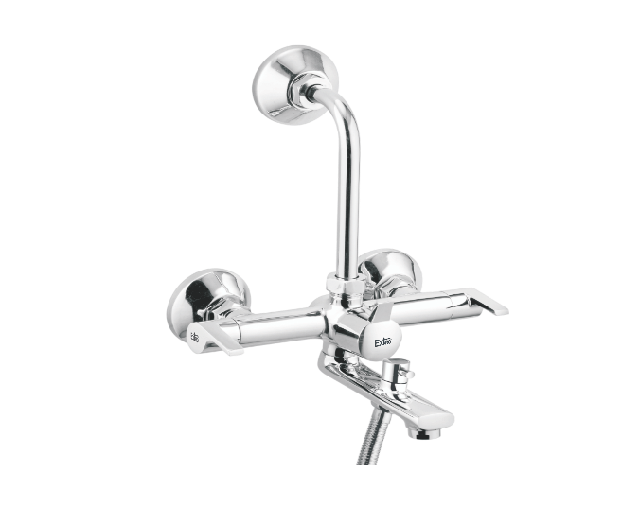

**Extro Basin Mixer with Dual Handle and Pop-Up Waste**

**Product Description:**

The Extro Basin Mixer with Dual Handle and Pop-Up Waste is a stylish and functional mixer faucet designed for deck-mounted installations, featuring separate hot and cold controls, a smooth chrome finish, and an integrated pop-up waste system for convenient drainage control.

**Key Features (Single-line format)**

✅ Dual handle design for precise hot and cold water control  
✅ Chrome-plated finish offers lasting shine and easy cleaning  
✅ Integrated pop-up waste system for added convenience  
✅ Brass body construction ensures durability and long life  
✅ Sleek, modern aesthetics ideal for premium bathrooms

**Product Specifications**

**Brand:** Extro  
**Model:** Dual Handle Basin Mixer with Pop-Up Waste  
**Material:** Solid Brass  
**Finish:** Chrome Plated  
**Mount Type:** Deck Mounted  
**Handle Type:** Dual Lever  
**Water Supply:** Hot and Cold  
**Drainage:** Integrated Pop-Up Waste  
**Connection Size:** 15 mm (½ inch BSP)  
**Application:** Wash basins in modern and premium bathrooms  
**Warranty:** Typically 5 Years (Confirm with dealer)

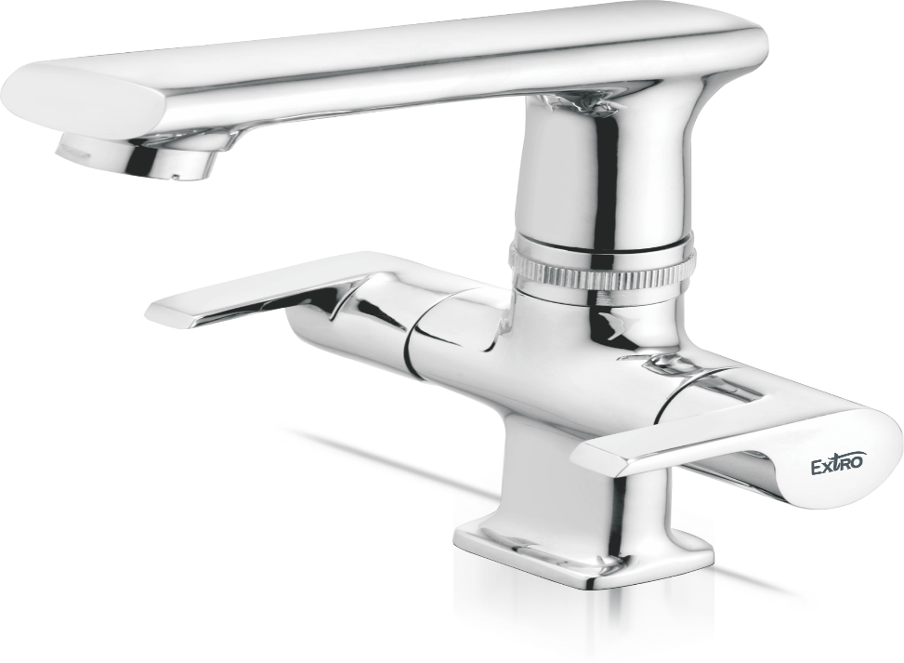

**Extro Single Lever Basin Mixer (Short Body)**

**Product Description:**

The Extro Single Lever Basin Mixer is a sleek and compact deck-mounted faucet designed for wash basins, combining smooth operation with a modern aesthetic and reliable performance.

**Key Features (Single-line format)**

✅ Single lever control for effortless temperature and flow adjustment  
✅ Chrome finish for mirror-like shine and corrosion resistance  
✅ Solid brass body enhances durability and strength  
✅ Compact design perfect for smaller basins and modern bathrooms  
✅ Smooth water flow with integrated aerator for efficiency

**Product Specifications**

**Brand:** Extro  
**Model:** Single Lever Basin Mixer (Short Body)  
**Material:** Solid Brass  
**Finish:** Chrome Plated  
**Mount Type:** Deck Mounted  
**Handle Type:** Single Lever  
**Water Supply:** Hot and Cold  
**Cartridge Type:** Ceramic Disc Cartridge  
**Connection Size:** 15 mm (½ inch BSP)  
**Application:** Wash basins in compact or contemporary bathrooms  
**Warranty:** Typically 5 Years (Confirm with dealer)

